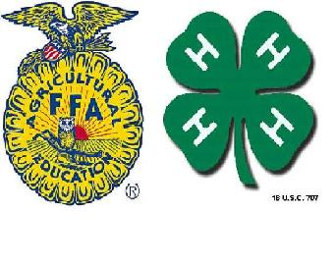

Trinity-Neches FFA & 4-H
Livestock Show & Rodeo
P.O. Box 787
Livingston, Texas 77351

Dear Exhibitor and Parent/Guardian:

Welcome to the 73rd Anniversary of the Trinity-Neches FFA and 4-H Livestock Show and Rodeo.

On behalf of the Board of Directors, we are honored to have you participate in our livestock show. We know you have spent many hours raising and taking care of your animals in hopes of having the Grand Champion dream come true.

Our volunteers have spent many hours getting ready to conduct the best show possible for you. We hope you have a rewarding experience that you will always remember.

We welcome you and thank you for participating in the 2018 Trinity-Neches FFA and 4-H Livestock Show and Rodeo.

Sincerely,

Lawrence Oliver
Chairman
Trinity-Neches FFA and 4-H Livestock Show
